17.7: 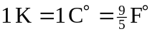, so a temperature increase of 10 K corresponds to an increase of 18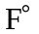. Beaker B has the higher temperature.

